Oracle 9g and 10g Testing

Running Orion ORacle IO Numbers
Orion IO Numbers suite is what Pillar uses to simulate Oracle running on a Windows, Sun Solaris, AIX and Linux. The version of Oracle IO Numbers that Pillar is using is Version 10.2.0.1.0
ORION runs IO performance tests that model Oracle RDBMS IO workloads. It measures the performance of small (2-32K) IOs and large (128K+) IOs at various load levels. Each Orion data point is done at a specific mix of small and large IO loads sustained for a peak duration parallel to the way in which Oracle processes data . Anywhere from a single data point to a two-dimensional array of data points can be tested by setting the right options.
An Orion test consists of data points at various small and large IO load levels. These points can be represented as a two-dimensional matrix: Each column in the matrix represents a fixed small IO load. Each row represents a fixed large IO load. The first row is with no large IO load and the first column is with no small IO load. An Orion test can be a single point, a row, a column or the whole matrix.
Parameters 'run', 'testname', and 'num_disks' are mandatory. Defaults are indicated for all other parameters. For additional information on the user interface, see the Orion User Guide.

Output Files
<testname>.lun should contain a carriage-return-separated list of LUNs
The output files for a test run are prefixed by <testname>_.
The output files are:
<testname>_summary.txt - Summary of the input parameters along with min. small
latency, max large MBPS and/or max. small IOPS.
<testname>_mbps.csv - Performance results of large IOs in MBPS
<testname>_iops.csv - Performance results of small IOs in IOPS
<testname>_lat.csv - Latency of small IOs
<testname>_tradeoff.csv - Shows large MBPS / small IOPS combinations that can
be achieved at certain small latencies
<testname>_trace.txt - Extended, unprocessed output
WARNING: IF YOU ARE PERFORMING WRITE TESTS, BE PREPARED TO LOSE ANY DATA STORED ON THE LUNS.

ORacle IO Numbers Parameters
Mandatory parameters:
Run Type of workload to run (simple, normal, advanced)
simple - tests random 8K small IOs at various loads,then random 1M large IOs at various loads.
normal - tests combinations of random 8K small IOs and random 1M large IOs
advanced - run the workload specified by the user using option parameters
testname Name of the test run
num_disks Number of disks (physical spindles)

Optional parameters:
size_small Size of small IOs (in KB) - default 8
size_large Size of large IOs (in KB) - default 1024

type Type of large IOs (rand, seq) - default rand, rand - Random large IOs, seq - Sequential streams of large IOs
num_streamIO Number of concurrent IOs per stream (only if type is seq) - default 4
simulate Orion tests on a virtual volume formed by combining the provided volumes in one of these ways (default concat): concat - A serial concatenation of the volumes raid0 - A RAID-0 mapping across the volumes
write Percentage of writes (SEE WARNING ABOVE) - default 0

cache_size Size *IN MEGABYTES* of the array's cache. Unless this option is set to 0, Orion does a number of (unmeasured) random IO before each large sequential data point. This is done in order to fill up the array cache with random data. This way, the blocks from one data point do not result in cache hits for the next data point. Read tests are preceded with junk reads and write tests are preceded with junk writes. If specified, this 'cache warming' is done until cache_size worth of IO has been read or written. Default behavior: fill up cache for 2 minutes before each data point. Duration. Duration of each data point (in seconds) - default 60
num_small Number of outstanding small IOs (only if matrix is point, col, or max) - no default
num_large For random, number of outstanding large IOs. For sequential, number of streams (only if matrix is point, row, or max) - no default.
Matrix An Orion test consists of data points at various smalland large IO load levels. These points can berepresented as a two-dimensional matrix: Each column in the matrix represents a fixed small IO load. Each row represents a fixed large IO load. The first row is with no large IO load and the first column is with no small IO load. An Orion test can be a single point, a row, a column or the whole matrix, depending on the atrix option setting below (default basic); basic - test the first row and the first column detailed - test the entire matrix, point - test at load level num_small, num_large, col- varying large IO load with num_small small IOsrow - varying small IO load with num_large large IOsmax - test varying loads up to num_small, num_large
Verbose Prints tracing information to standard output if set. Default -- not set

Script Examples
For a preliminary set of data
-run simple -testname <name> -num_disks <#>
For a basic set of data
-run normal -testname <name> -num_disks <#>
To generate combinations of 32KB and 1MB reads to random locations:
-run advanced -testname <name> -num_disks <#>
-size_small 32 -size_large 1024 -type rand -matrix detailed
To generate multiple sequential 1MB write streams, simulating 1MB RAID0 stripes
-run advanced -testname <name> -num_disks <#>
-simulate RAID0 -stripe 1024 -write 100 -type seq
-matrix col -num_small 0

Reading Output Files
Orion creates several output files. Continuing the “mytest” example, these files are explained below:
mytest_summary.txt: This file contains: Input parameters:
- Maximum throughput observed for the Large Random/Sequential workload
- Maximum I/O rate observed for the Small Random workload
- Minimum latency observed for the Small Random workload
mytest_mbps.csv: Comma-separated value file containing the data transfer rate (MBPS) results for the Large Random/Sequential workload. This and all other CSV files contain a two-dimensional table. Each row in the table corresponds to a large I/O load level and each column corresponds to a small I/O load level. Thus, the column headings are the number of outstanding small I/Os and the row headings are the number of outstanding large I/Os (for random large I/O tests) or the number of sequential streams (for sequential large I/O tests).
The first few data points of the Orion MBPS output CSV file for “mytest” are shown below. The simple mytest command-line given earlier does not test combinations of large and small I/Os. Hence, the MBPS file has just one column corresponding to 0 outstanding small I/Os. In the example below, at a load level of 8 outstanding large reads and no small I/Os, we get a data throughput of 103.06 MBPS.
Large/Small, 0 1, 19.18 2, 37.59 4, 65.53 6, 87.03 8, 103.06
10, 109.67 .. ... .. ...
The following chart illustrates the data transfer rate measured at different large I/O load levels. This chart can be generated by loading mytest_mbps.csv into Microsoft Excel or OpenOffice and graphing the data points using the application. Orion does not directly generate such graphs. The x-axis corresponds to the number of outstanding large reads and the y-axis corresponds to the throughput observed.
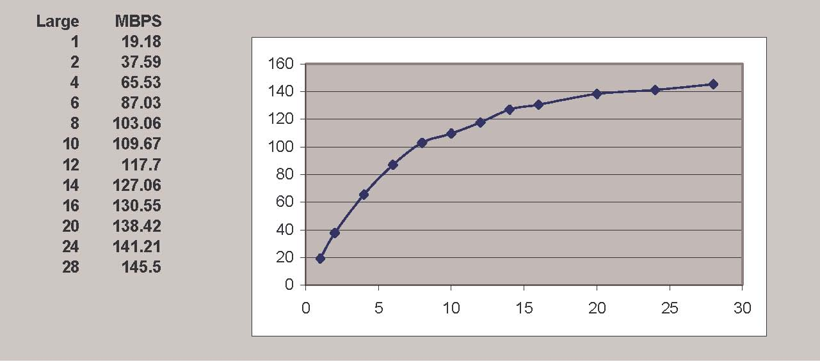
mytest_iops.csv: Comma-separated value file containing the I/O throughput (in IOPS) results for the Small Random workload. Like in the MBPS file, the column headings are the number of outstanding small I/Os and the row headings are the number of outstanding large I/Os (when testing large random) or the number of sequential streams (for large sequential).
In the general case, this CSV file contains a two-dimensional table. However, for the simple mytest command-line given earlier, we aren’t testing combinations of large and small I/Os. Hence, the IOPS results file just has one row with 0 large I/Os. In the example below, with 12 outstanding small reads and no large I/Os, we get a throughput of 951 IOPS.
Large/Small, 1, 2, 3, 6, 9, 12 . . . .
0, 105, 208, 309, 569, 782, 951 . . . .
The graph below (generated by loading mytest_iops.csv into Excel and charting the data) illustrates the IOPS throughput seen at different small I/O load levels.
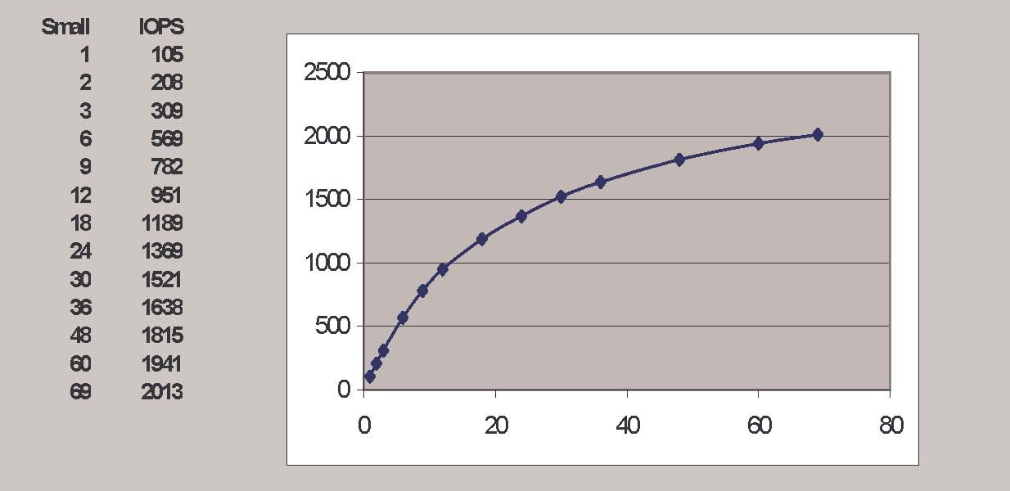
mytest_lat.csv: Comma-separated value file containing the latency results for the Small Random workload. Like in the MBPS and IOPS files, the column headings are the number of outstanding small I/Os and the row headings are the number of outstanding large I/Os (when testing large random I/Os) or the number of sequential streams.
In the general case, this CSV file contains a two-dimensional table. However, for the simple mytest command-line given earlier, we don’t test combinations of large and small I/Os. Hence, the IOPS results file just has one row with 0 large I/Os, as shown below. In the example below, at a sustained load level of 12 outstanding small reads and no large I/Os, we get an I/O turn-around latency of milliseconds.
Large/Small, 1, 2, 3, 6, 9, 12 . . . .
0, 14.22, 14.69, 15.09, 16.98, 18.91, 21.25 . . . .
The following graph (generated by loading mytest_lat.csv into Excel and charting the data) illustrates the small I/O latency at different small I/O load levels for mytest.
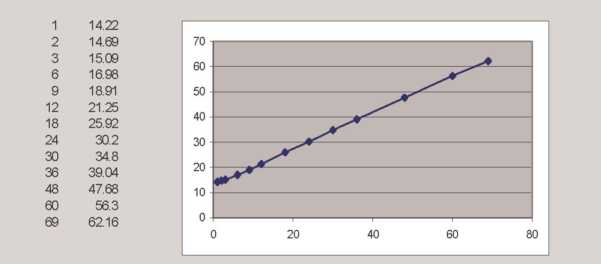
mytest_trace.txt: Contains extended, unprocessed test output.
Except for mytest_trace.txt, if any of these files already exist, they will be overwritten. Each run of Orion appends to mytest_trace.txt (or the equivalent trace file name for your test name).
NOTE: IF ANY ERROR OCCURS DURING THE TEST, IT WILL BE PRINTED TO STANDARD OUTPUT.

